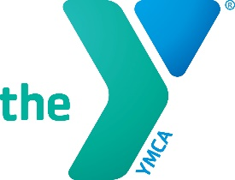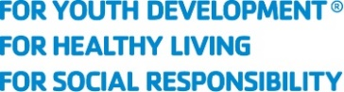

North Carolina Alliance of YMCAs Overview
- The Alliance is a coalition of the 25 independent, nonprofit YMCA associations in North Carolina.
- The Alliance builds the capacity of the state’s YMCAs, fosters collaboration on statewide initiatives, advocates on behalf of the Y’s mission, and coordinates communication to build consensus that ensures Ys are recognized as leaders in youth development, health living and social responsibility.
- Together, NC Ys serve nearly 1 million people statewide through membership and programs, and they serve even more during times of crisis.
- For media inquiries, contact Michele McKinley at michele.mckinley@ymcatriangle.org. We can also connect you to local Ys.
About Our YMCAs
Mission:
To put Christian principles into practice through programs that build healthy spirit, mind and body for all.
Vision:
The Y’s Commitment to America is developing new generations of changemakers who will create communities we all want to live in. We envision communities where all people achieve health, gain confidence, make connections and feel secure at every stage of life.
Purpose:
The Y is a leading nonprofit committed to strengthening community by connecting all people to their potential, purpose and each other.
Working locally, we focus on empowering young people, improving health and well-being, and inspiring action in and across communities.
By bringing together people from different backgrounds, perspectives and generations, we ensure that we all have access to the opportunities, relationships and resources necessary to learn, grow and thrive.

We’re for Youth Development, Healthy Living and Social Responsibility.

